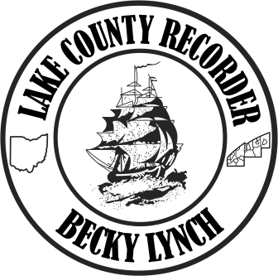

**BECKY LYNCH**

[Becky.Lynch@LakeCountyOhio.gov](mailto:Becky.Lynch@LakeCountyOhio.gov)

(440) 350-2510 (440) 918-2510

EASTERN LAKE COUNTY WESTERN LAKE COUNTY

(440) 350-5940

FAX

**For Immediate Release:**

**LAKE COUNTY RECORDER ‘ESSENTIALLY’ BLESSED! DONATES $500 TO LOCAL CHARITY**

April 20, 2020 Painesville, Ohio; When the Lake County Recorder Office was declared ‘essential’ by the Governor they could not ‘stay home’, cut back staff or remote work. So they adapted and became essentially blessed! Lake County Recorder Becky Lynch credits the outstanding performance of her deputies during the Covid challenges! “After the crisis-changes and ‘essential’ designation, we stayed true to form and dedicated to purpose,” says Lynch, “our staff has braved the storm of Covid like the true professionals they are.” When the county buildings needed to limit access, we reacted by accommodating customers with drop-box deliveries and extended temporary services to help keep recording services accomplished. Each day a steady and productive effort is achieved by the Recorder Office Staff, to preserve the ‘essentially’ reconfigured ‘routine’ during the crisis.

Recorder Lynch appreciates her staff and all their extra efforts have not gone unnoticed. Today, Lynch received a letter of recognition and appreciation from long time technology vendor Fidlar Technologies, Inc., for Lake County and the Recorder Office, “The responsibilities that your office and the county provide are one of those essential services that people depend on. As your land records vendor, we are incredibly honored to call all of you our partners”, said Fidlar Technologies Owners Ernest Riggen and Dave Steil, “You understand the impact of halting the recording of documents and you have found ways to keep functioning, while still protecting your staff and constituents.”

Out of the darkness of Covid comes the light of well-placed confidence in good partnerships! Recorder Becky Lynch says, “We are all ‘essentially’ blessed, I’m thankful and honored to lead the Recorder efforts in Lake County with the gift of a great staff…the ‘essential’ part of the equation!” Fidlar Technologies, Inc. has participated in the successes of the Lake County Recorder Office in many ways over more than 20 years. The Recorder accepts and acknowledges this wonderful gesture for our community, “To thank you for your efforts and partnership, we are offering a donation of $500 to the local charity of your choice. In these trying, times, we believe it’s important to give back and support the communities who are so vital to our customers.” Congratulations to Lake County and the Recorder Office!

*For more information, contact the Lake County Recorder’s office at 440-350-2510.* Guidelines are updated regularly at the Recorder website [www.LakeCountyOhioRecorder.com](http://www.LakeCountyOhioRecorder.com).

*Contact Becky Lynch for information - -Office 440-350-2510 Cell 678-662-8839*

Recorder Office:

Becky Lynch,

Recorder

Anthony Ticconi,

Chief Deputy

Mary Pat Keyes,

Office Manager,

Deputy Recorder

Diane Barrish,

Deputy Recorder

Shaun Brown,

Deputy Recorder

Sandee Collins,

Deputy Recorder

Lisa Felder,

Deputy Recorder

Simone Jackson,

Deputy Recorder

Denise Thompson,

Deputy Recorder

Curt Wagner,

Deputy Recorder