ODH County Positivity Data Update
4/23/21 10:00am

Dr. Bruce Vanderhoff
- Monday, April 26, 2021 county test PCR positivity data will be added to dashboard at https://coronavirus.ohio.gov/wps/portal/gov/covid-19/dashboards/overview
- Took a long time to validate data and establish a process, wanted the data to be correct.
- County positivity rate data should be factored along with other factors (case number, ED visits, outpatient visits
- Media availability 4/23/21 at 11am to notify this is coming on Monday.
- Positivity Rates will be sent to locals on Monday around 1pm. Public posting at 2pm.

Sample
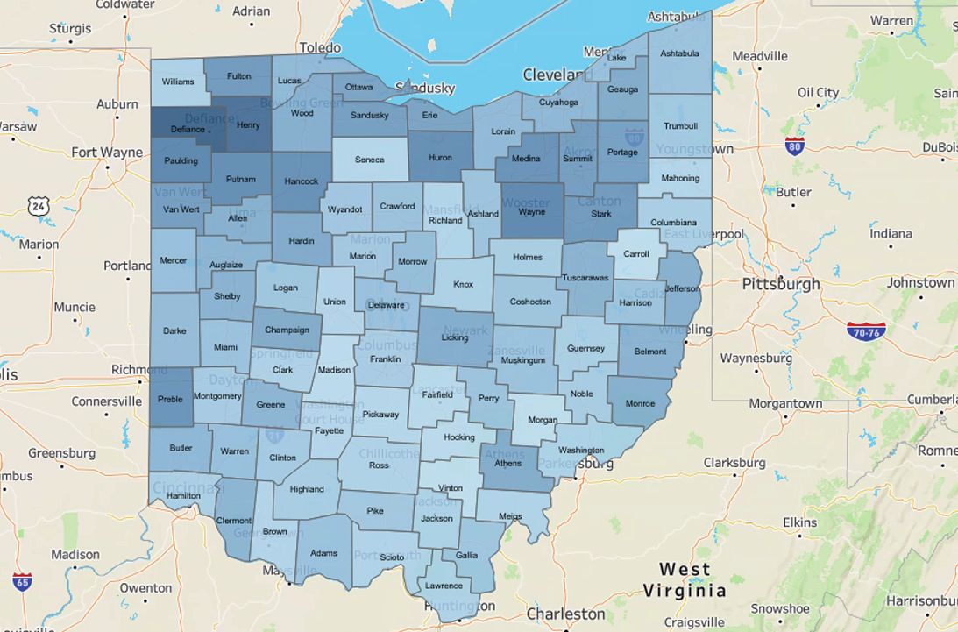

- Counties will be colored by gradient based on number of tests administered. Counties with less than 20 tests per week will be very light blue.
- County level map will update weekly on Mondays.
- Based on previous two-week period.
- Will be able to download CSV file too.

Q/A
- Q: Will LHD info be able to view on the backend more often than weekly? A: No, not at this time.
- Q: What is the formula used to create the data? A: Total electronic submitted positives vs. total electronic submissions.
- Q: Will all testing modalities remain the same? A: Yes.
- Q: How are out of county tests/out of state tests included? A: Will find answer.
- Q: Are antigen/home testing being separated out/monitored? A: PCR only at county-level.
- Q: Will this be different than CMS data? A: No, this is the same data.
- Q: Are all reporting labs included? A: Trying to achieve this. May be a small number of outliers not reporting.
- Q: Will this map also include variant positivity rate? A: No

