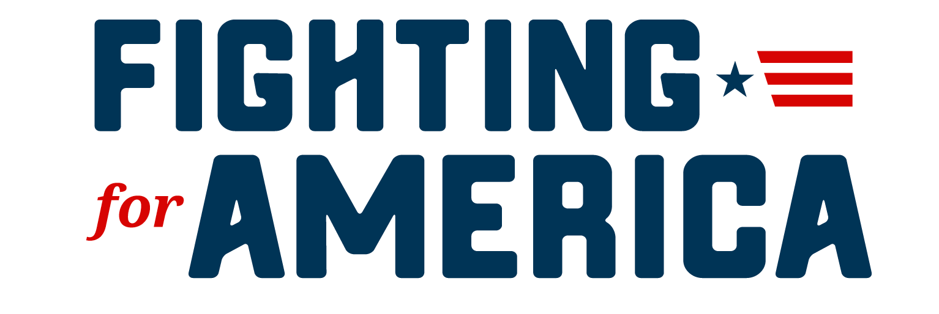
FREEDOM TO CHOOSE
Why the Ohio Republican Party needs Ethical Reform NOW!

We all know instinctively that when we go to the deli and see the butcher put their thumb on the scale - that this practice is both unethical and illegal.

We know that if we catch the butcher placing his thumb on the scale that he is at the very least defrauding us and that if we do not report the act to law enforcement the butcher will continue to steal from us and other patrons. At the very least, we all should make the decision to not patronize that deli again. Some may even feel that they have a duty to their fellow man to stand up and do what is right and report the butcher.

Guess what? Ohio Republicans are consciously making the decision to not be “patrons” (members) of the Republican party because they do not see enough Republicans in charge standing up for what is right. They see SCC content with the status quo (political elites placing their thumb on the scale). The status quo is supremely arrogant individuals that believe they must make political decisions for the public because those in the public are too dumb to make intelligent decisions on their own. The way the Ohio Republican Party makes money is to attach themselves at the hip to candidates like a leech instead of standing for a platform of conservative solutions with a mission and vision to get things done. Our ORP will not champion state issues and hold candidates accountable to a State Republican platform. They have refused to do their duty in creating a State - based platform for many years. This reached an obvious and overt crescendo when former Governor John Kasich spoke at the Democrat National Convention and former Chairman Matt Borges joined with Democrats on the Lincoln Project to steal the election from President Trump. The party has become an amorphous ever-shifting blob of political sand with no backbone.

We believe, at the Committee for a Better Ohio, that the State Central Committee has a very important job to do. That it should do so with the honesty of an Eagle Scout and with the fierceness of a Marine.

The truth is that political organizations, such as parties are essential to the proper conduct of government - city, county, state, or national. America has a government “of the parties and by the parties” which is a result of the free assembly of the people. Political parties bring people together to enact proper controls on the government, develop policies favorable to their interests or the groups that support them, and organize and persuade voters to elect their candidates to office. Without the effective organization of the parties by the people, there would be no competent parties representing the will of the people in government. When political parties become weak and ineffective due to poor organization and complacency, then a government incompetent in representing the will of the people is a result.

“With great power comes great responsibility”

Stan Lee of Marvel Comics may have made up this adage for comic book great the Amazing Spiderman, it is however, so relevant to party politics. With the great power of party politics comes the thoughts of evil men to corrupt and game the system of the party.

Every time party leadership tries to unfairly engineer the system in favor of a “selected” candidate our freedom of choice is diminished. The invisible hand of the market is compromised and a monopoly can, and will form. Many of us call these monopolies the swamp. Political monopolies do not benefit Ohio Republicans nor help to march conservative issues down the field towards the goal post. Monopolies enrich and empower those that run the monopoly. Certainly, this does not mean that the party cannot win elections, it has and continues to win elections - but every year true Republicans become disenchanted with the party. Support for Common Core, support for Obamacare, support for higher taxation, support of Critical Race Theory, support for BLM, the support of the changing of gender on birth certificates, failure to pass photo identification requirements, etc...etc..these failures continue to plague the party in turning Ohio into a solidly red State. Yet, Donald Trump and Ronald Reagan easily won this state with decidedly much more conservative messages. The reason why we cannot get more conservatives elected is due to the Republican elites putting their thumb on the scale and illicitly choking out their more conservative competition. Underhanded, unsportsmanlike, cheating, dishonorable, dishonest, shady, and dodgy are all adjectives used to describe party leadership that come with consequences.

The Ohio Republican party should strive to ensure fairness, transparency and to make certain that the will of the people is not ignominiously engineered but is derived through competition of political campaigns and education of the candidates and the policies they support.

It is very important for all political organizations to be above board and transparent in all their dealings and activities. Besides compliance - being honest and transparent helps to foster trust and engenders greater giving and better volunteer efforts. How much more dominant could the Ohio Republican party be if they embraced ethical behavior?

The Committee for a Better Ohio was shocked by the revelation that the Ohio Republican Party has donated in excess of $870,000 to Mike DeWine and over $550,000 to David Yost, both candidates have yet to be endorsed. The much more troubling and disconcerting vista was that most of the Republican State Central Committee (SCC) members were caught unaware of this transpiring. Are the members asleep at the wheel?

The bylaws for the Ohio Republican State Central Committee are very poorly written (to the point that they are a joke...thanks Brickler and Eckler) but pretty specific on endorsements and funds being distributed. However, no one on the State Central Committee wants to report any wrongdoing even though they believe wholeheartedly that what has transpired is wrong by every reasonable standard. Most are fearful of retribution by State Republican leadership and some fear for the loss of their job or loved one’s job because they work for the State or were appointed by the Governor.

The Details

To be perfectly clear, the $559,774.59 worth of transactions to Dave Yost through the Ohio Republican Party State Candidate fund violates the Ohio Revised Code 3517.102(B)(6)(b)(i). This amount was distributed from the Ohio Republican Party (ORP) State Candidate’s fund and is over the $500,000 allowable threshold by law.

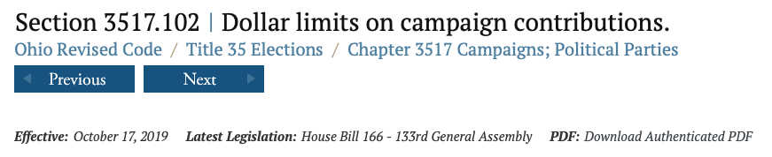
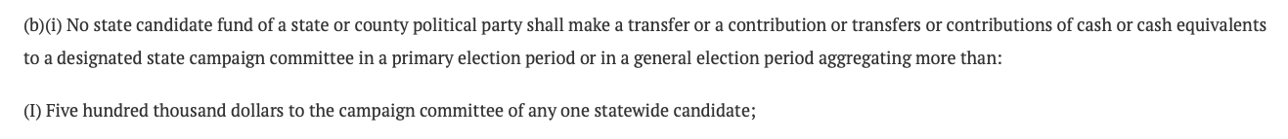

The distributions made to the DeWine Campaign fund are just as questionable. The report on the Secretary of State’s website classifies the $500,000 as coming from an individual that has the same address as the address of the Ohio Republican Party headquarters. It is not a non-individual transaction (which means it is classified as coming from an individual and not the party - which is troubling - as there are no individuals that live at party headquarters.) There was also $370,967.68 that was donated from the state candidates fund to put the total in excess of $870k given to the DeWine campaign.

The explanation for the dollar value above the legal limit that has been given to many SCC members is that Ohio law allows for joint fundraising with the party that allows a candidate to exceed maximum donations by having a joint fundraising contract with the ORP. Yet, all the SCC members that we have talked to know of no joint fundraising contracts that they have approved.

Keep in mind that section 7 of article 3 of the ORP bylaws state "No officer or member of the Committee shall have any power to bind this Committee by any financial contract or obligation except as provided by these rules, or by resolution properly adopted by a majority of the members of the Committee present and voting and properly recorded by the Secretary in the minutes of the Committee. “
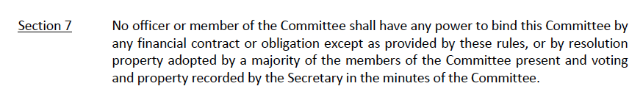
And further the bylaws state that Article 6 Section 2 Paragraph d that "ORP candidate services will only be used in a primary campaign when the candidate is supported in accordance with the primary policy guidelines.“
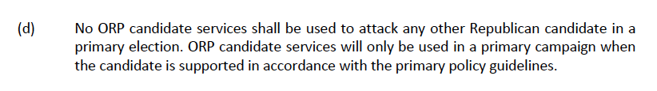

In talking with many of the State Central Committee members, they do not recollect adopting primary policy guidelines and none of them have voted to endorse any candidate. This would seem to indicate that misappropriation of funds occurred. In Ohio, misappropriations of funds is a type of criminal embezzlement with harsh penalties for public officials that breach the public’s trust. Ohio Revised Code 2913.02 states “No person, with purpose to deprive the owner of property or services, shall knowingly obtain or exert control over either the property or services…...Without the consent of the owner or person authorized to give consent”

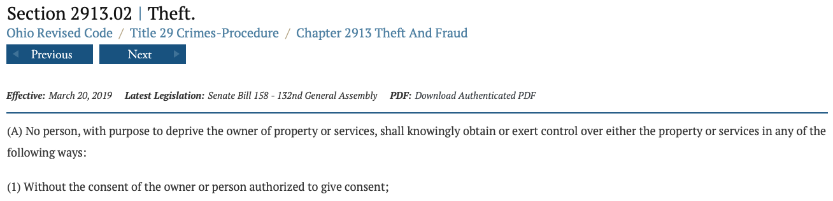

The property in question here are the funds of the party (SCC funds). The ability to distribute these funds are dependent upon consent (authorization) by the SCC. The only way this could happen is with a properly adopted resolution. According to the bylaws, Bob Paduchik and Dave Johnson absolutely cannot unilaterally decide to write a check or provide support to an unendorsed candidate without a properly adopted resolution.

But let’s say there was the language in the ORP bylaws that possibly allows Bob Paduchik and Dave Johnson to make unilateral disbursements to candidates of their choosing (therby making the State Central Committee irrelevant.) This type of transaction would still be illegal under Ohio’s ethics laws.

So the question then goes to whose idea was it and who approved the disbursements? Both Bob and Dave have a conflict of interest.

There has been no end to the speculation that the only reason for Bob Paduchik to take the job as chairman was to ensure another four years for Mike DeWine. Bob, after all, worked on DeWine’s Senate campaign in the 1990’s. Bob Paduchik has had a business relationship with Mike DeWine. The treasurer of the ORP (David Johnson) has told the Committee for a Better Ohio that he highly supports and endorses Mike DeWine. David Johnson is also a political appointee to the Ohio Bureau of Worker’s compensation by DeWine. Given David and Bob Paduchik’s relationship with the Governor, they absolutely have to recuse themselves as public officials from any votes and decisions for the ORP to support Mike DeWine - they cannot even legally make calls to try to influence support for Mike DeWine.

Just about any way you try to slice it, there was a law broken in distributing funds to Mike DeWine. The question is now, how serious is the violation?

Do the Right Thing
We know that the ORP has given to many of the Statewide candidates without them being endorsed by the SCC - that is literally the definition of the thumb on the scale. Yet, most SCC members knew nothing about these distributions in advance and were caught unaware. Are they asleep at the wheel? Or, is it that leadership is conspiring behind their backs? A good chairman keeps their members informed and educated. It is inexcusable that the Chairman did not keep all SCC members informed.

If we want to preserve our freedom to choose - each candidate can pay back the funds plus interest -or- the ORP should make equal contributions to their competitor’s campaigns. We all know full well that this will not happen.

If you have had enough of the games being played - now is the time to stand up and be heard and fight back. Or, you are one of the people that is okay with the butcher’s thumb on the scale and you are one that is okay with having your freedom of choice diminished.

Even if you are supportive of Mike DeWine and David Yost, you can still be against these transactions that make a mockery of the value of the SCC.

What can you do?

- You can write your State Central Committee member and voice your frustration with unethical behavior. You can encourage them to provide an affidavit to the Franklin County Prosecutor of possible wrongdoing (misappropriation of funds while in office).
  - Franklin County Prosecutor
The Honorable G. Gary Tyack
373 S High St.
Columbus, OH 43215
- You can write your State Central Committee member and encourage them to sue Republican leadership for misappropriation of funds.
- You can write your County Central Committee member and voice your frustration with the State Central Committee and urge them to draft a resolution of no-confidence of the SCC.
- You can send an affidavit to the Ohio Elections Commission using the information provided in this letter. We will be providing you a link of an example affidavit.
  - Ohio Elections Commission
Suite 1850 Riffe Center
77 South High St.
Columbus, Ohio 43215
- You can call the Ohio Ethics Commission and request and allegation form:
  - (614) 466-7090

