Proposal for Geauga County/Laketran Contract for Public Transit Service
October 2022

Problem Statement
The Geauga County Transit Development Plan was initiated by the Ohio Department of Transportation (ODOT) Office of Transit to determine the feasibility of increased coordination between Laketran and Geauga County Transit. An interest in increased partnership under the existing collaboration was expressed to ODOT by both parties. At present, coordination exists through shared use scheduling and dispatching technology, maintenance services, passenger transfers between the two systems, and an agreement for pass-through of Federal Transit Administration (FTA) Section 5307 funding for technology. Increased coordination could reduce the level of effort necessary for effective transit grants administration, ODOT/FTA compliance, and fundraising for grant local match.

Recommended Coordination Model
To obtain input on potential coordination arrangements, RLS conducted one-on-one interviews with two Geauga County Commissioners, two Lake County Commissioners, and eight Laketran board members. One additional Laketran board member provided written feedback to RLS. RLS also conducted in-depth one-one-one and small group discussions with Laketran and Geauga County Transit system management staff, and conducted on site tours of both transit systems. Additionally, RLS reviewed recent service, performance and financial data for each system.
The following coordination models were explored in discussions with the transit systems’ leaders:
- Status Quo – no changes to the existing relationship between Geauga County Transit and Laketran.
- Laketran becomes the FTA/ODOT grant recipient and forms a contract with Geauga County for Geauga service, with employees remaining as Geauga County employees (a purchasing relationship).
- Laketran becomes the FTA/ODOT grant recipient; Geauga County and Laketran form a contract for administration and operation of Geauga service; Laketran absorbs the staff and vehicles with service’s identity remaining as Geauga County Transit. (Recommended model)
- Geauga County remains as the FTA/ODOT grant recipient and contracts with Laketran for additional services beyond the existing scheduling/dispatching technology and maintenance services.
- Laketran becomes the FTA/ODOT grant recipient, absorbs Geauga staff and vehicles and becomes a 2-county provider (total consolidation).
Following the discussions with County Commissioners, board members, staff, and ODOT, RLS recommends that Geauga County move forward with the model described in #3. The Geauga County Commissioners and the Laketran board of directors would form a five-year Memorandum of Agreement
(MOA) designating Laketran as the recipient of FTA/ODOT grant funding for transit operations in Geauga County. Geauga County Transit would become a distinct department of Laketran, retaining its existing identity, local-level management, operating model, and facility.

Recommended Geauga County Transit-Laketran Coordination Model

Anticipated Cost Savings and Revenue Increase
Geauga County Transit’s costs will be reduced in multiple areas over the life of the agreement. The following chart depicts trends in the system’s costs from 2017 through the budgeted expenses for 2023.
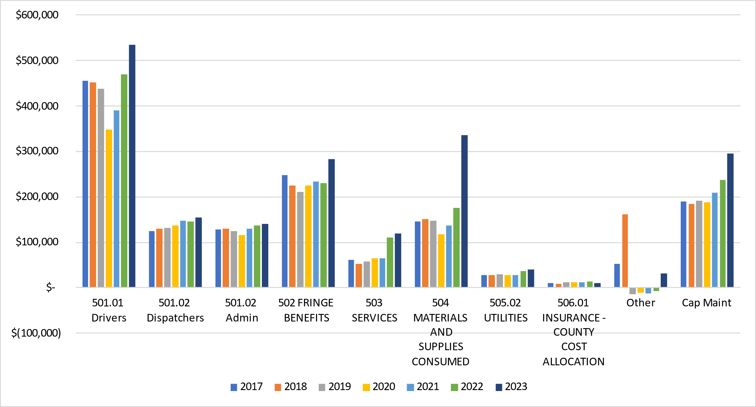

Under the coordination model, positive fiscal impacts will be realized in multiple areas. Estimates for fiscal impacts in the areas of administrative and customer service staffing, maintenance, and contracted transportation revenue are provided in the following sections. Additional savings are expected in the areas of fuel costs and advertising revenue.

Reduced Administrative and Customer Service Staffing Costs
The coordination model will allow Geauga County Transit to benefit from the expertise of Laketran’s administrative and customer service staff. Under the model, it is anticipated that a small number of Geauga County Transit positions will be consolidated with Laketran’s staffing over a five-year period. No positions will be eliminated during Year 1 of the contract. In Years 2 through 5, it is anticipated that four positions will be eliminated due to attrition. As staff members leave the system, their functions will be consolidated with existing Laketran staff members’ duties. The following table provides the expected annual costs for staffing and fringe benefits in Years 1 through 5.
Labor and Fringe Benefits Cost Comparison
Status Quo |  | Year 1 | Year 2 | Year 3 | Year 4 | Year 5
501 Labor | Operations - Drivers | $550,712 | $567,234 | $584,251 | $601,778 | $619,831
501 Labor | Operations - Administration/  Dispatching | $303,969 | $313,089 | $322,481 | $332,156 | $342,120
501 Labor | Capitalized Maintenance | $146,293 | $150,682 | $155,202 | $159,858 | $164,654
502 Fringe | Fringe Benefits | $352,096 | $362,659 | $373,539 | $384,745 | $396,287
 | Total Labor/Fringe | $1,353,071 | $1,393,663 | $1,435,473 | $1,478,537 | $1,522,893
Coordination Model |  | Year 1 | Year 2 | Year 3 | Year 4 | Year 5
501 Labor | Operations - Drivers | $550,712 | $561,276 | $571,977 | $589,136 | $606,810
501 Labor | Operations - Administration/  Dispatching | $303,969 | $295,215 | $187,927 | $193,565 | $160,791
501 Labor | Capitalized Maintenance | $146,293 | $144,724 | $142,929 | $147,217 | $151,633
502 Fringe | Fringe Benefits | $352,096 | $351,326 | $315,173 | $324,629 | $309,600
 | Total GCT Labor/Fringe | $1,353,071 | $1,352,540 | $1,218,006 | $1,254,547 | $1,228,834
 | Phase-In of Laketran Customer Service (Labor/Fringe) | $0 | $0 | $45,820 | $45,820 | $91,641
 | Total Labor/Fringe | $1,353,071 | $1,352,540 | $1,263,827 | $1,300,367 | $1,320,475
 | Difference (Savings) | $(0) | $(41,123) | $(171,646) | $(178,170) | $(202,418)

Projected Savings: The total savings associated with consolidated administrative and customer service staffing over the five-year period is projected to be $593,358.

Reduced Capitalized Maintenance Expenses
Under Laketran’s Equivalent Service Plan (an exemption from accessible fleet standards under the Americans with Disabilities Act), Geauga County Transit will gain the ability to acquire inaccessible vehicles with lower operating costs. These vehicles could include small vans and sedans. These vehicles will have lower fuel and maintenance costs than the cutaway buses and ADA-accessible minivans in the current Geauga County Transit fleet.
Additionally, Laketran’s unit costs for maintenance are lower than Geauga County Transit’s costs due to economies of scale. Laketran’s cost per mile for fuel and maintenance of gasoline-powered vans is currently $0.49. Applying this cost to Geauga County Transit’s fleet would result in annual fuel and maintenance costs of $235,120 (assuming total fleet mileage that is equivalent to pre-pandemic 2019 levels). The system’s 2023 budgeted maintenance cost is $314,132, with fuel at $304,750. While this fuel amount is likely overestimated due to the per-gallon assumed cost of $5.75 (a reasonable expectation at the time the budget was written), it is apparent that overall fuel and maintenance costs under Laketran will be lower.
Projected Savings: need on unit cost of Laketran maintenance w/o fuel

Increased Human Service Transportation and Advertising Revenue
Coordination with Laketran will allow Geauga County Transit to provide Medicaid-funded transportation under Laketran’s enrollment as a provider with the Ohio Department of Medicaid. Geauga County and nearby areas have a large unmet demand for Medicaid transportation. Providing these rides will allow Geauga County Transit to generate significant locally derived revenue to use as grant match. Geauga County Transit does not currently have the staffing capacity to provide the extensive administrative oversight required to maintain enrollment as a Medicaid provider.
Geauga County Transit formerly raised approximately $250,000 per year in human service transportation contract revenue. At present, the system’s director expects to raise approximately $120,000 in the current budget year, primarily through contracting with Geauga County Board of Developmental Disabilities. Laketran estimates that Geauga County Transit can generate enough Medicaid income to restore human service transportation revenue to previous levels.
Secondly, the coordination model will allow Geauga County Transit to participate in Laketran’s on-vehicle advertising program. It is expected that advertising revenue will increase under Laketran’s program, which is larger and more competitive.
Projected Revenue Increase: It is anticipated that Medicaid revenue will increase by approximately $25,000 annually over the 5-year period. Medicaid rides will increase incrementally over time as Geauga County Transit increases operating efficiency and builds its reputation with Medicaid agencies and clients.
Contracted Transportation Revenue Increase
Coordination Model |  | Year 1 | Year 2 | Year 3 | Year 4 | Year 5
Revenue | Medicaid | +$25,000 (total: $145,000) | +$25,000 (total:  $170,000) | +$25,000 (total:  $195,000) | +$25,000 (total: $220,000) | +$25,000 (total:  $245,000)

Reduced Materials and Supplies Costs (Fuel)
Fuel costs represent the largest category within Geauga County Transit’s Materials and Supplies budget. Fuel costs were projected to be $5.75 per gallon in 2023. The 2023 budget estimated usage of 53,000 gallons of fuel over the year.
Laketran bids out its fuel on an annual basis. The agency’s current cost assumption is $3.50 per gallon (diesel and gasoline) for 295,000 gallons in 2022. Laketran participates in a fuel purchasing consortium with other transit agencies. Coupled with its access to more efficient vehicles through Laketran’s Equivalent Service Plan, Geauga County Transit’s inclusion in this procurement will ensure a cost savings due to economies of scale.
Projected Savings: The precise amount of fuel savings cannot be forecasting due to volatility in fuel pricing. However, participation in a fuel procurement consortium and the ability to run smaller vehicles is very likely to result in significant savings. In the past, Laketran has saved more than $1 per gallon on fuel, when comparing its price to the market rate, as a result of participating in the consortium. This level of savings would result in a $53,000 cost annual cost savings for Geauga County Transit.

Total Projected Financial Impact of Coordination Model
A summary table providing the financial impact of the coordination model is provided below.
Financial Impact of Coordination Model for Geauga County Transit
Coordination Model | Year 1 | Year 2 | Year 3 | Year 4 | Year 5 | Total for 5-Year Period
Cost Savings - Labor and Fringe Benefits | $0 | $41,123 | $171,646 | $178,170 | $202,418 | $593,358
Cost Savings - Maintenance
Revenue Increase | $25,000 | $50,000 | $75,000 | $100,000 | $125,000 | $375,000
Total Savings/  Revenue Increase | $25,000 | $91,123 | $246,646 | $278,170 | $327,418 | $968,358

Identified Strengths, Opportunities and Benefits
RLS facilitated a SWOT (strengths, weaknesses, opportunities, and threats) workshop with Geauga County Transit and Laketran staff in July 2022. This SWOT analysis summarizes the positive aspects of the coordination model, and identifies potential negative outcomes that can be mitigated through leadership efforts during implementation.

Strengths
- Laketran direct bills the State of Ohio for Medicaid trips, which is requisite for receiving Medicaid revenue for contracted client trips. Laketran’s eligibility will be extended to the Geauga County Transit fleet and drivers under the coordination model.
- The two agencies have an established successful partnership and strong rapport. They already partner on scheduling/dispatching software, contracted maintenance, and FTA Section 5307 funding.
- Laketran maintains an Equivalent Service Plan with the FTA which allows for the procurement and operation of non-accessible vehicles, which are cost-efficient to operate. Non-accessible vehicles are an efficient mode for performing trips or the Amish population. About 50% Geauga County Transit trips are provided to Amish customers. Creating and getting approval for an Equivalent Service Plans is an intensive administrative process that would not be feasible for a small rural system.
- Coordination would introduce economies of scale in many areas (e.g., fuel procurement, parts and supplies acquisition, and on-vehicle advertising) that would increase to Geauga County Transit’s cost-efficiency.
- Geauga County Transit would benefit from the expertise of Laketran’s leadership team. Laketran’s top-level managers specialize in areas such as FTA grants management, regulatory compliance, safety planning, and information technology.
- Risk and administrative burden associated with the transit system are eliminated for Geauga County.
- Through increased cost-efficiency, more local match funding, and more access to grants, Geauga County Transit service will be able to increase. The end results will be more rides for Geauga County residents.

Weaknesses
- The coordination model will introduce concerns about the job security of Geauga County Transit staff members.
  - Mitigation strategy: Under the coordination model, Geauga County Transit anticipates only a minor reduction in staff (4 full-time equivalents) over the five-year period. This will be communicated to staff following the acceptance of the model by the Geauga County Commissioners and Laketran board.
- Implementation of the coordination model will require significant upfront work effort, particularly by Laketran management staff.
  - Mitigation strategy: Laketran has created a proposal and budget for startup costs during 2023. The major costs will include the expansion of Laketran’s phone system and information technology network to Geauga County Transit; onboarding of staff as Laketran employees; writing the Section 5311 grant application; setting up a new cost center in Laketran’s accounting system; transferring vehicles and updating Laketran’s TAM plan; and initial communications and public relations efforts targeting transit staff, customers, and the public. ODOT has indicated willingness to fully fund Laketran’s upfront costs.

Opportunities
- There are multiple opportunities for resource sharing between the two transit systems under the proposed model. Some have already been identified in this document. Sharing resources will allow Geauga County Transit to access cost-efficiencies, management expertise, and more advanced technologies. An expansion of Laketran’s scope and size is likely to generate more purchasing power and increases its stature within Ohio’s and the nation’s transit industry, resulting in new opportunities for funding and innovation.
- Closer coordination between the two agencies will make it easier to offer cross-county demand response trips in the future. The process of coordinating rides between the Laketran Dial-A-Ride and Geauga County Transit fleets will be simplified. The interviews conducted for this study revealed that there is demand for cross-county trips for work, medical, shopping and other purposes by residents who live near the county line.
- Laketran has dedicated training staff who will be available to offer increased training opportunities for Geauga County Transit drivers, dispatchers, and maintenance staff.
- Laketran has full-time staff members who specialize in procurement and grant writing, which will ease some of the administrative burden at Geauga County Transit.

Threats
- Lake County taxpayers support Laketran through a sales tax levy. There may be some concern about Lake County tax dollars funding another county’s transit service.
  - Mitigation strategy: Laketran will establish a separate cost center for Geauga County Transit in its accounting system. The revenue sources for Geauga County Transit expenses will be clearly identified. Expenses and revenues specific to Geauga County Transit will be clearly identified in all Laketran financial reporting. Laketran’s leadership, including the Director of Communications/Public Information Officer and CEO, will devise a clear communications strategy for upfront and ongoing public communication about the coordination model. This strategy will be oriented toward explaining the separation between the revenue sources for the two transit systems. Additionally, Geauga County Transit will retain its own local identity and branding, so Laketran vehicles will only be seen within Geauga County on rare occasions, including if and when cross-county trips are authorized.
- Stakeholders may have high expectations for the coordination model that may not be met until later in the five-year period. Cost-efficiencies may take multiple years to realize.
  - Mitigation Strategy: Laketran and Geauga County Transit management will communicate progress in implementing the model and realizing new efficiencies throughout the five-year period. Routine reports will be provided to the Geauga County Commissioners and Laketran board of directors. The five-year Transit Development Plan will identify performance measures related to productivity and cost-efficiency, which will be tracked and reported by system leadership.

Implementation Timeline
- Draft MOA provided by RLS to Laketran and Geauga County Transit by December 1, 2022.
- MOA considered and adopted by Geauga County Commissioners and Laketran board of directors by February 28, 2023.
- Laketran applies for Geauga ODOT grant for Fiscal Year 2023-2024 in April, 2023.
- Laketran implements phone system and information technology in Geauga County in Spring 2023.
- Staff positions and fleet transfer to Laketran effective July 1, 2023.

