MEDIA RELEASE:
Contact: David Schick
The Lake County Alcohol, Drug Addiction and Mental Health Services (ADAMHS) Board
Phone: 440-350-2193
Email: DSchick@LakeADAMHS.org

FOR IMMEDIATE RELEASE
Local Prevention and Recovery Efforts Show Strong Community Impact in Lake County
CAP Scorecard Results (2023–2025) Highlight Progress in Overdose Prevention, Workforce Growth, and Access to Care
Mentor, OH — The Lake County Alcohol, Drug Addiction and Mental Health Services (ADAMHS) Board has released outcome data from its 2023–2025 Community Assessment & Plan (CAP), showing measurable progress in overdose prevention, peer support services, access to care, and child safety across the county.
Under Ohio law, local ADAMHS Boards must submit a Community Assessment & Plan to the Ohio Department of Behavioral Health (DBH) that identifies community needs and outlines priorities for prevention, treatment, and recovery support. The Lake County ADAMHS Board’s latest scorecard demonstrates how those efforts are making a difference locally.
Over the three-year period, the Board exceeded key goals tied to overdose prevention and peer support, while also seeing encouraging improvements in insurance coverage and family stability.
Among the most significant findings:
Overdose prevention efforts surpassed expectations, with 1,293 naloxone kits distributed throughout the community—exceeding the original goal of 1,200. The county also made major strides in expanding its peer support workforce. While the three-year goal was to train 10 peer supporters, a total of 35 were trained, including 17 in 2025 alone.
Access to care improved as the percentage of uninsured adults declined from 6.5% to 4.9%. Child safety outcomes also showed strong improvement, with only one child removed from their home in 2025 due to parental substance use.
Although referrals to Child Protective Services increased slightly, the total remains far below the high in 2023 and well under the three-year target of 250.
Some community health indicators remained unchanged, including youth illicit drug use, adult depression, heavy and binge drinking, and adult poor mental health days. Daniel Rowles, Director of Quality & Clinical Operations stated, “Note that stability is meaningful, particularly as many communities nationwide are experiencing sharp increases in behavioral health concerns.”
Among pregnant women with substance use disorders, 101 pregnant women and mothers were screened, with 24 admitted for residential treatment. While this fell short of the projected 50, the data highlights ongoing barriers such as housing, childcare, and transportation that affect access to treatment.
“These numbers show that our community is working—especially in lifesaving overdose prevention, peer support, and child safety,” said Rowles. “At the same time, the data reminds us that prevention and mental health support must remain a long-term priority.”
The Lake ADAMHS Board and Ohio DBH will use the CAP results to guide future strategies and strengthen partnerships across prevention, treatment, and recovery systems.
For more information, contact David Schick at the Lake County ADAMHS Board at 440-350-2193 or DSchick@LakeADAMHS.org.
Caption: OPUS 216 performs at Lake County’s first “Concert of Hope” on Overdose Awareness Day (August 31), honoring lives lost and celebrating recovery while promoting awareness of substance use, overdose prevention, and local support services.
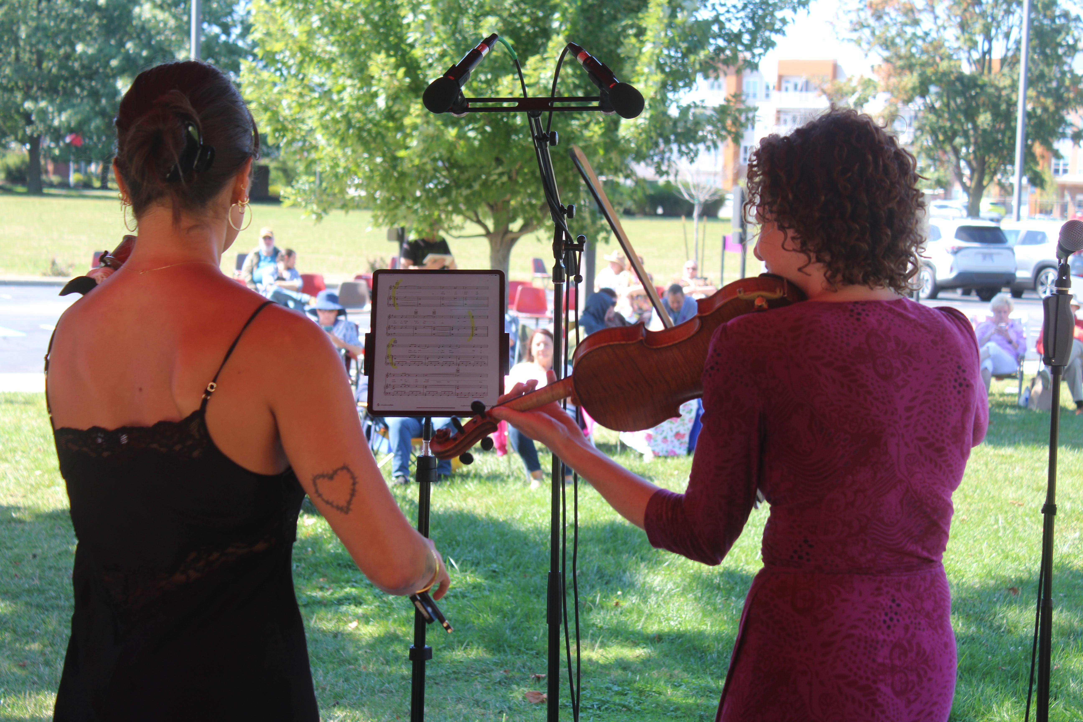

Caption: Sandra Tenkku of the Lake County ADAMHS Board speaks with residents at the Wickliffe Senior Center, sharing information on prevention, treatment, and support services. Older adults are a growing population in Lake County, and outreach efforts like this help ensure seniors know help and resources are available.
